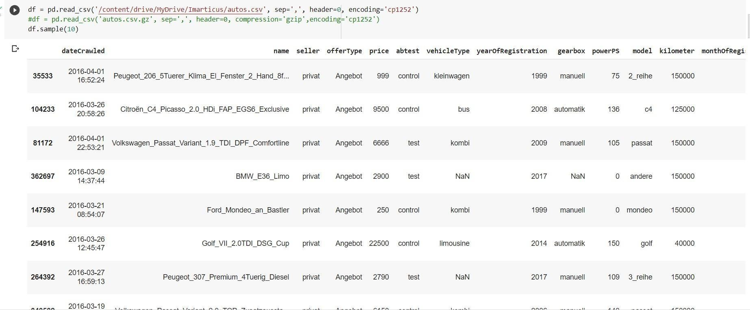

**PROJECT**

**DEVELOPMENT**

**PHASE**

**DELIVERY**

**OF**

**SPRINT**

**-**

**1**

DATE

29

OCTOBER

2022

TEAM

ID

PNT2022TMID

36315

PROJECT

NAME

Car

Resale

Value

Prediction

MAXIMUM

MARK

4

Marks

•

**Import**

**library**

**and**

**load**

**dataset**

**in**

**python**

 

•

**Understanding**

**and**

**Analyzing**

**the**

**dataset**

**by**

**Correlation.**

 

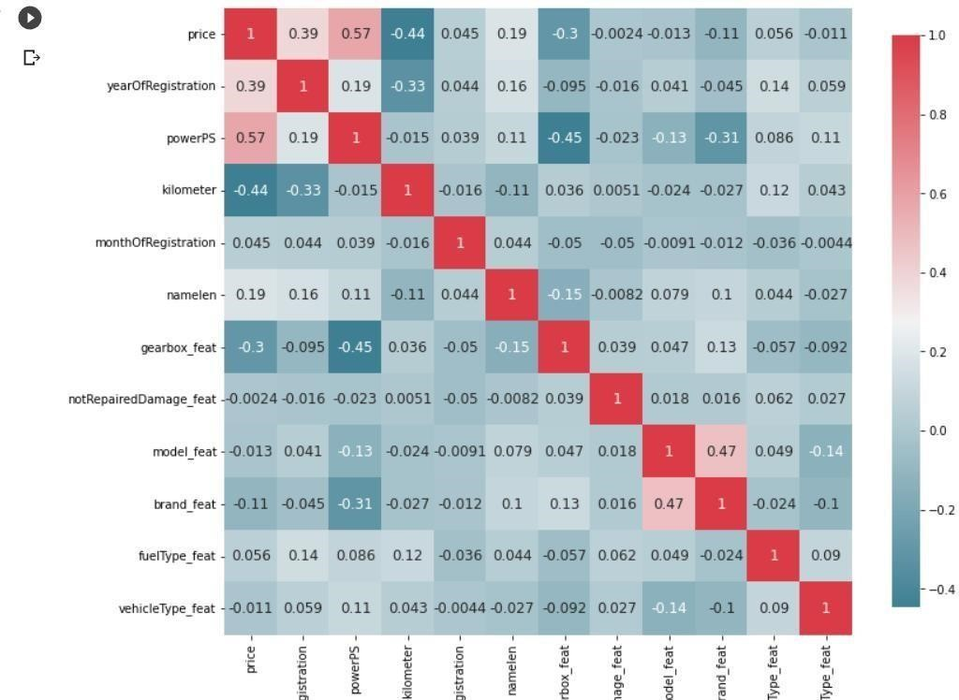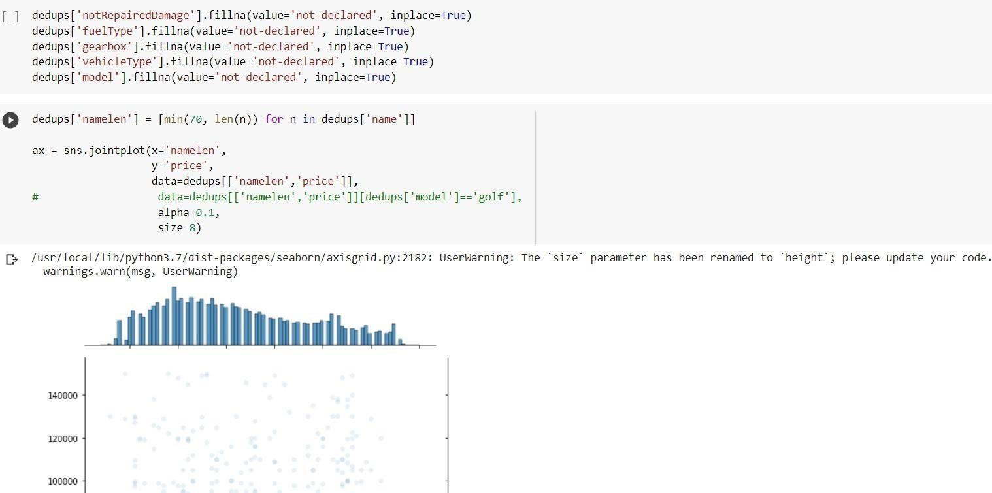

•

**Clearing**

**null**

**values**

 

•

**Preprocessing**

**the**

**categorical**

**values**

 

